# Mapping the Alaskan Moho

Meghan S. Miller 1 and Louis Moresi 2

1 *Australian National University, Research School of Earth Sciences, Canberra, ACT 2601*

2 *University of Melbourne, School of Earth Sciences, Parkville, VIC 3010*

## Abstract

We present a series of Moho depth maps for the Alaskan region based upon P receiver function estimates using data from all available broadband instrumentation from 1999 to April 2018 including the USArray Transportable Array. The average Moho depth beneath individual broadband stations are presented first as spot measurements and then used to produce a series of interpolated smooth surfaces by an adaptive triangulation process followed by the fitting of a bi-cubic spline. The interpolated surfaces include a measure of confidence in the interpolation and can be used to assess and determine a preferred model. The resulting Moho depth map (single continuous surface) provides a reasonable estimate of the Earth’s outermost layer thickness beneath Alaska as constrained by receiver functions, for use in applications such as tomography, regional-scale interpretations, or simulations of seismic waves. The models are provided as a python module with examples in the form of Jupyter notebooks. Our original workflow is provided to allow updates to this dataset or use with other similar datasets.

## Introduction

The Alaskan crust is composed of a mosaic of oceanic and continental terranes that range in age from Proterozoic to Cenozoic (Plafker and Berg, 1994). These terranes have been deformed and displaced through geologic time, yet their structure reflects both their origins and the heterogeneous distribution of strain. Due the remote and harsh conditions in much of the region there has been very sparse broadband seismic data coverage outside of south-central Alaska until recently.

In September 2017 the final USArray Transportable Array (network code TA) seismic station was installed in Alaska. This was the last of 280 instruments deployed as a grid across Alaska and northwest Canada as part of the EarthScope program which was proposed nearly 20 years ago (Meltzer et al., 1999; Rosen 2017). This is the final stage of the continent-wide experiment that has been ongoing since 2004. These instruments complement and greatly expand the number and distribution of seismic stations that have previously, or are permanently operating. The data from all these seismic stations allows construction of a map of the average crustal architecture, along with investigation into deeper structure and a more comprehensive seismicity catalog for the surrounding region.

With the current distribution of broadband instruments across Alaska there is an opportunity to make a regional map of Moho (Mohorovičić discontinuity) depth, assumed to coincide with the crust-mantle boundary, or Moho. Although locally the Moho can be incredibly complex and have variations in depth and magnitude of the velocity contrast across the boundary, an estimate of the crust-mantle boundary structure is very important for geological and geophysical research. Crustal models such as CRUST5.1 (Mooney et al., 1998) or CRUST2.0 (Bassin et al., 2000), and more recently ones such as those based on EarthScope data (Gilbert, 2012; Levander and Miller, 2012; Tape et al., 2012) and the EARS (EarthScope Automated Receiver Survey) project (Crotwell and Owens, 2005; IRIS DMC, 2010) have been very valuable for the solid Earth community. Here we used all available data (1999-2018) from broadband instruments to compute P receiver functions, then determined the Moho depth at each station from the stacked receiver functions in order to make a series of maps of the Moho depth including a smoothed surface. We note that although there are some areas across the state that still have limited data, others that are very densely instrumented, and in addition areas of very complex crustal structure. This map, plus the associated measures of confidence may be useful by the community until there are future improvements on this model.

## Instrument Deployment

Five hundred and five broadband seismic stations have been deployed across Alaska and Yukon Territory (Figure 1), which have open access data that can be obtained from the IRIS Data Management Center (DMC) at [www.iris.edu](http://www.iris.edu) (last accessed April 2018). The seismic stations are from multiple networks, both permanent and temporary (see electronic supplementary Table S1 for DOI numbers), with the bulk of these from the EarthScope Transportable Array (network code TA) and the Alaska Regional Network (network code AK).

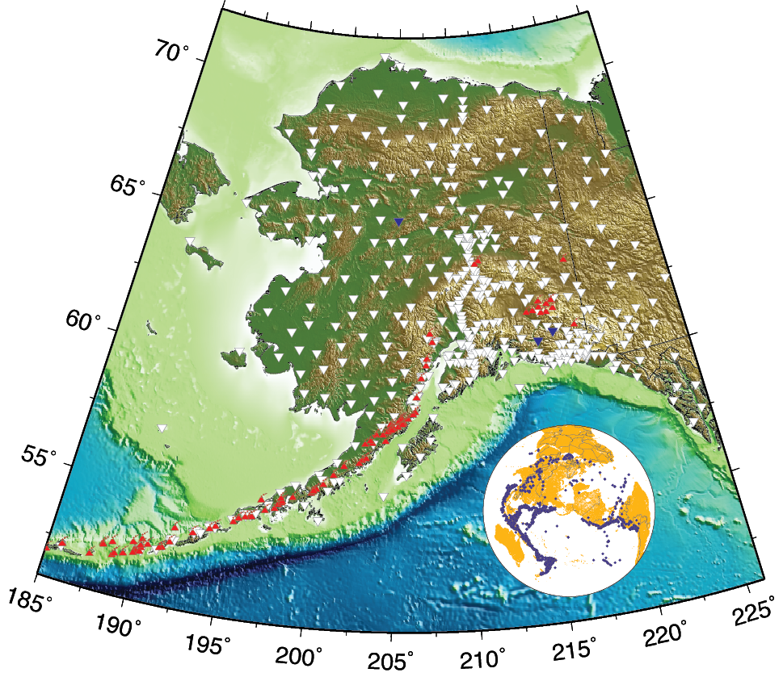

*Figure 1. Distribution of broadband seismic stations used in the analysis, which were accessible from the IRIS data management center (*[*www.iris.edu*](http://www.iris.edu) *accessed April 2018), shown as inverted white triangles. Active volcanoes are shown with red triangles (Smithsonian Global Volcanism Program). Inset shows the distribution of earthquakes (blue dots) used in the analysis. Blue inverted triangles indicate the location of the stations shown in Figure S1.*

## Overall Data Quality and Availability

A range of broadband seismic data from teleseismic earthquakes that occurred between 1999 through April 2018 (inset Figure 1) were selected and processed (see Data and Resources for more details). These waveform data were obtained within the Funclab software (Eagar and Fouch, 2012; Porritt and Miller, 2018) via the irisFetch.m MATLAB script (Trabant et al., 2012). The data were chosen for events with magnitudes >M6.0 at epicentral distances between 30-98.3 degrees. This resulted in a total of 2179 earthquakes and 505 seismic stations, which yielded 136,838 preliminary P receiver functions (PRFs) calculated in Funclab. The PRFs were calculated using iterative time-domain deconvolution (Ligorria and Ammon, 1999) of the vertical component from the radial and transverse components using a 1 Hz central frequency. These were manually edited with the FuncLab trace editor based on high signal-to-noise direct arrivals and clean traces, resulting in a final total of 36,370 PRFs. A subset of these results and the methodology used in the processing are discussed in Miller et al. (2018). These receiver functions are based upon detailed, manual inspection and selection of all the waveforms and resulting receiver function, which is unlike the fully automated data product, EARS (Crotwell and Owens, 2005) available at <https://doi.org/10.17611/DP/EARS.1>.

The individual receiver functions are stacked at each station using a simple summation to improve the signal-to-noise ratio and emphasize coherent conversions (examples shown in Figure S1, available in the electronic supplement to this article). This stacking can eliminate more complex or subtle signals from anisotropy or dipping structures, but does provide an effective way to enhance the primary signals from sub-horizontal velocity discontinuities like the Moho. These gathers are converted from time to depth using the *ak135* 1D velocity model (Kennett et al., 1995) to provide an estimate of the average structure at depth beneath each station. To provide a broad scale Moho depth map across the region, the Moho conversions were hand-picked for each of the receiver function stacks within FuncLab (Porritt and Miller, 2018). These picks are used as spot measurements of the average Moho depth at each seismic station to create a simple map as shown in Figure 2 and are provided in Table S2, available in the electronic supplement to this article.

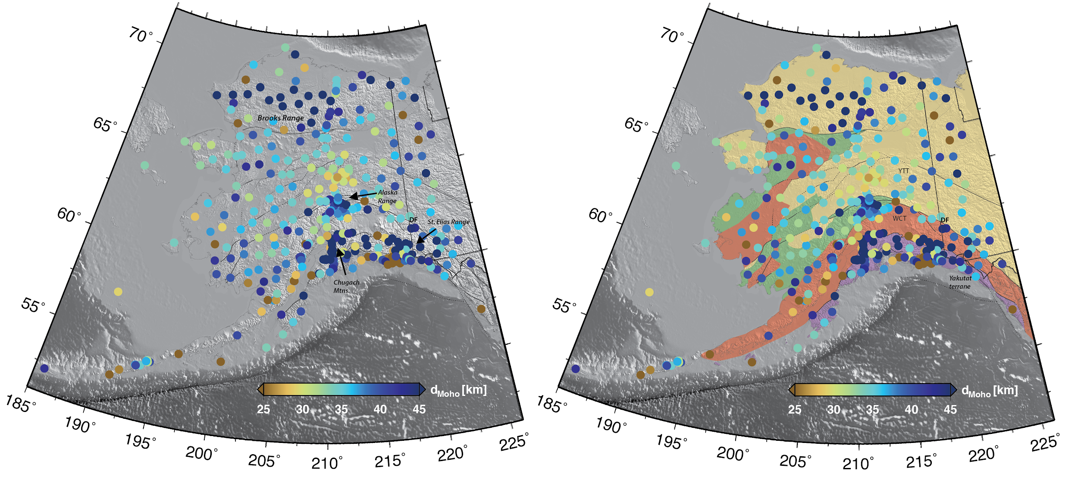

*Figure 2. A) Moho depth estimates at station locations shown as colored dots. Major faults are indicated with thin black and grey lines, dashed where approximately located. B) Moho depth map with simplified litho-types overlain with the faults (Wilson et al., 2015, Miller et al., 2018). Map colors denote broad crustal categories of terranes, based primarily on dominant bedrock geology and isotopic characteristics: yellow—continental and marginal basins, including Yukon Tanana terrane (YTT); orange-red—ocean plateau and arc, including the Wrangellia composite terrane (WCT); green—clastic marine basins; purple—accretionary complex.*

## Observations

In September 2017 the Transportable Array was fully installed across Alaska and into the bordering regions of Canada (Rosen, 2017) and this provides the first region/state-wide glimpse of the crustal thickness. Although there are still some areas of limited data and some areas of very complex signals in the receiver functions, the Moho depth map (Figure 2) presents a new overview across this vast area. There is a primary trend, despite the large area, that the crustal thickness roughly correlates with topography. The high topography in the Alaska, St. Elias and Brooks Ranges and even the Chugach Mountains, for example, have deep Mohos (Figure 2). There are also abrupt changes in Moho depth across terrane boundaries and faults, such as the Denali fault (DF) system as documented previously (e.g. Veenstra et al., 2006; Brennan et al., 2011; Allam et al., 2017 Miller et al., 2018), but also at across other terranes boundaries. An example of these terrane boundaries are between the Yukon-Tanana (YTT) and Wrangellia composite terranes (WCT) that have previously been under sampled by seismic data (Figure 2B). There are other indications that the inferred terranes and litho-boundaries may also have distinct structural changes across them as seen in the litho-type simplified map in Figure 2B (Wilson et al., 2015; Miller et al., 2018).

The receiver functions typically have a very clear, simple signal of the Moho as shown in Figure S1A for station TA.H20K in north-central Alaska. However, within the accretionary complex (purple in Figure 2B), the majority of the Moho picks are > 35 km and can reach down to nearly 60 km (Table S2, available in the electronic supplement to this article). However, the crustal structure is not as simple as the map of local averaged measurements portrays. The individual receiver functions are remarkably complex, which is likely due to the collision and subsequent subduction of the Yakutat terrane and the downgoing Pacific plate. At some stations there are “two Mohos” and at others there is no shallow (overriding) plate conversion in the signal (Figures S1B - AK.VRDI and S1C - AK.BMR). This is particularly evident along the southern margin of Alaska when the Pacific plate is subducting and the Yakutat terrane is colliding and being subducted. There are large differences in the Moho depth estimates at closely spaced stations. This is likely to be due to not being able to image one Moho or one discontinuity within the crust. This is discussed in Miller et al. (2018), which presents the P receiver functions in more detail. It is essential to be cautious and understand the geology and tectonics, and the methodology used in the seismic imaging, when using the Moho picks from stacked receiver functions and not solely use the Moho map to understand complex tectonics.

## Results

The Moho depth associated with individual stations is a useful first step at interpreting the crustal architecture. However, an interpolated surface of the Moho within the survey area, along with a measure of the confidence in such an interpolation is important to understand the extent to which Moho values can be interpreted away from the measurement location, which is important for interpretations. The Moho surface can be used as a starting model for other seismological and geophysical methods used to infer Earth structure.

### Smooth, interpolated model

A piecewise linear interpolant can be constructed from a Delaunay triangulation of the data points (Figure 2 and Table S2, available in the electronic supplement to this article) but the irregular spacing of the instruments produce artefacts in interpolation that suggest it may be more appropriate to apply some smoothing. The STRIPACK and SSRFPACK routines (Renka 1997a,b) are used to construct triangulations and spline interpolants for the data. However, the spacing is irregular enough that the fitting procedure employed by SSRFPACK does not converge for any value of the smoothing parameters. Instead we build a triangulation using a smaller number of nodal points with an interpolating spline that we can use as a model to be fitted to the data.

To build an interpolating surface, we first find a set of mesh points that reasonably represents the distribution of the data while also being sufficiently regular that it is possible to construct the spline surface accurately. A simple approach to finding a set of $p_{1}$ nodal points to represent the instrument locations is to use a clustering algorithm on the coordinate vectors. We used the k-means clustering from scipy (Jones et al, 2001) with random initial centroids to provide sets of nodes for triangulation. The random nature of the mesh construction means that we cannot determine the influence of $p_{1}$ from a single realisation of the mesh and instead we need to average over a large number of meshes. A second parameter, $p_{2}$, for the model is associated with the degree of tensioning of the interpolating splines. A value of zero corresponds to bilinear interpolation, larger values produce increasingly smooth results with a scale that depends on the number of sample points and the statistics of the noise in the data. As the latter is not well known in this case, we view $p_{2}$ as a free parameter to be determined.

### Fitting the model 1: confidence estimates

We make a first pass through the data to identify the extent to which individual data points can be fitted by our choice of a single-valued, continuous interpolating surface. We systematically exclude each point from the data set and use the other data points to predict its value for 20 different realizations of the triangulations for all values of the model parameters ($p_{1},p_{2})$. Each time, we identify the containing triangle of every observation and attribute a distance weighted average contribution to each node of this triangle. The predictions of the model for each data point can be evaluated by computing the mean (Figure 3A) and r.m.s variation (Figure 3B) of the values.

We then attribute a score (Figure 3C) to each of the data locations based on their predictability: points where the mean error and variance are both small receive a score of 1 — these points are reliable but may not be good at discriminating between models. Points where small errors are possible with some combination of parameters are accorded an additional score of 1. Nodes where models are consistently unreliable are accorded a score of 0.1. The scores for each observation location are mapped to grid points by distance-weighted averaging and used to provide the node-by-node confidence estimate required by SSRFPACK.

The complexity of signals in the receiver functions and therefore the simple, average estimate of Moho depth beneath each station can lead to high variance between the different model realizations (Figure 3B). There are a number of points where no smooth, continuous model can fit the observation. This is likely due to the receiver functions ability to image multiple interfaces, not just the Moho, and the variable magnitude of the signal from these velocity contrasts at variable depths. These complexities make it difficult to pick the true Moho if there is a clear velocity contrast from this discontinuity. Therefore, our estimate of error is highest in regions where the Moho picks (Figure 2) have differences between closely spaced stations. This might better be represented as a multi-valued surface, as we are likely to be imaging multiple layers, but, in this preliminary analysis, we simply report these as points where the score for the chosen model parameterization is low.

### 

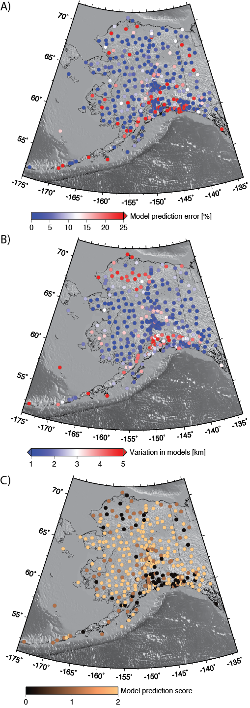

*Figure 3: (A) Mean errors and (B) rms variation about the mean in the prediction of each data point using information from all other data points and a uniform error assumption to compute the model interpolant. The measures are averages over all model parameters for each data point. (C ) is the model score extracted from the measures in (A,B).Fitting the model 2: choice of parameters*

We construct 250 triangulations for each value in the range of $p_{1}$. For every triangulation, we partition the data into two: one set of points (70-95%, chosen at random) is used to fit the data for each of values chosen for the smoothing parameter, $p_{2}$ and the remaining points used to evaluate the prediction error of the resulting interpolants. several The results are processed to determine the fit to the test data for each pair of $p_{1}, p_{2}$ using the node-by-node confidence score in Figure 3C to weight the depths in the spline fit.

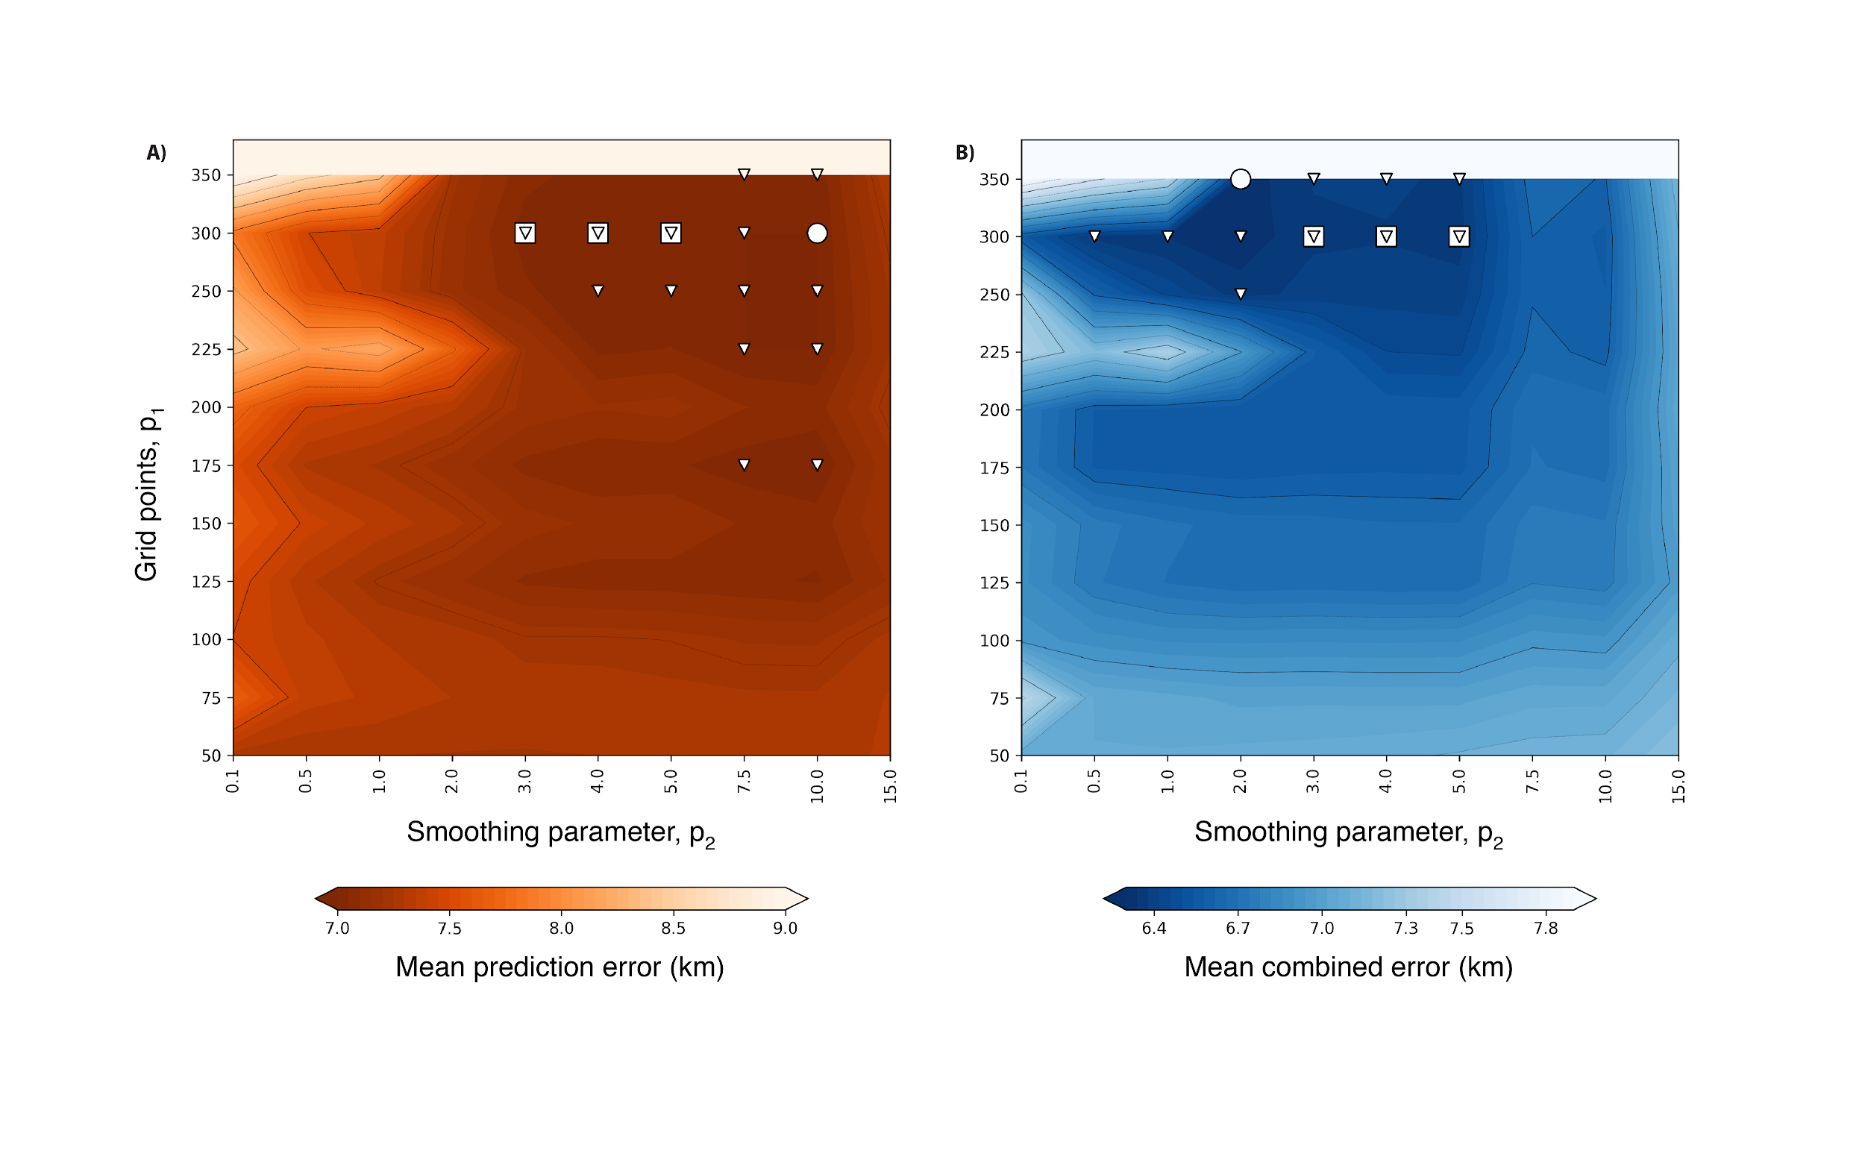

*Figure 4. The mean error (A) from 250 realizations in predicting the test data for $p_{1},p_{2}$ and the mean error (B) for predicting all data (test and training). The white circle is the minimum value for each case. The triangles lie within 1.25% of the minimum error. The white squares are the points which lie in the 1.25% range of both measures.*

The process of fitting the model is summarized in Figure 4 using two alternative measures of fit over all the different grids and partitioning of the data. In one case (Figure 4A) we show the fit only to the test data sets, and in the second case (Figure 4B), we form a combined error which is the misfit for all the data, including the training data. Around the best fitting points in each case are a number of models with a misfit within 1.25% of the minimum value. The models based only on fitting the test data are the smoothest models that satisfy the observations whereas those that minimize the combined error are more likely to over-fit the data. There are several models which are within 1% to 2% of the minimum of each of the measures and these appear to represent a good balance between overfitting and over-simplifying the model. Our preferred model is an average of these cases; we also include the two end member best-fit models for the purposes of comparison.

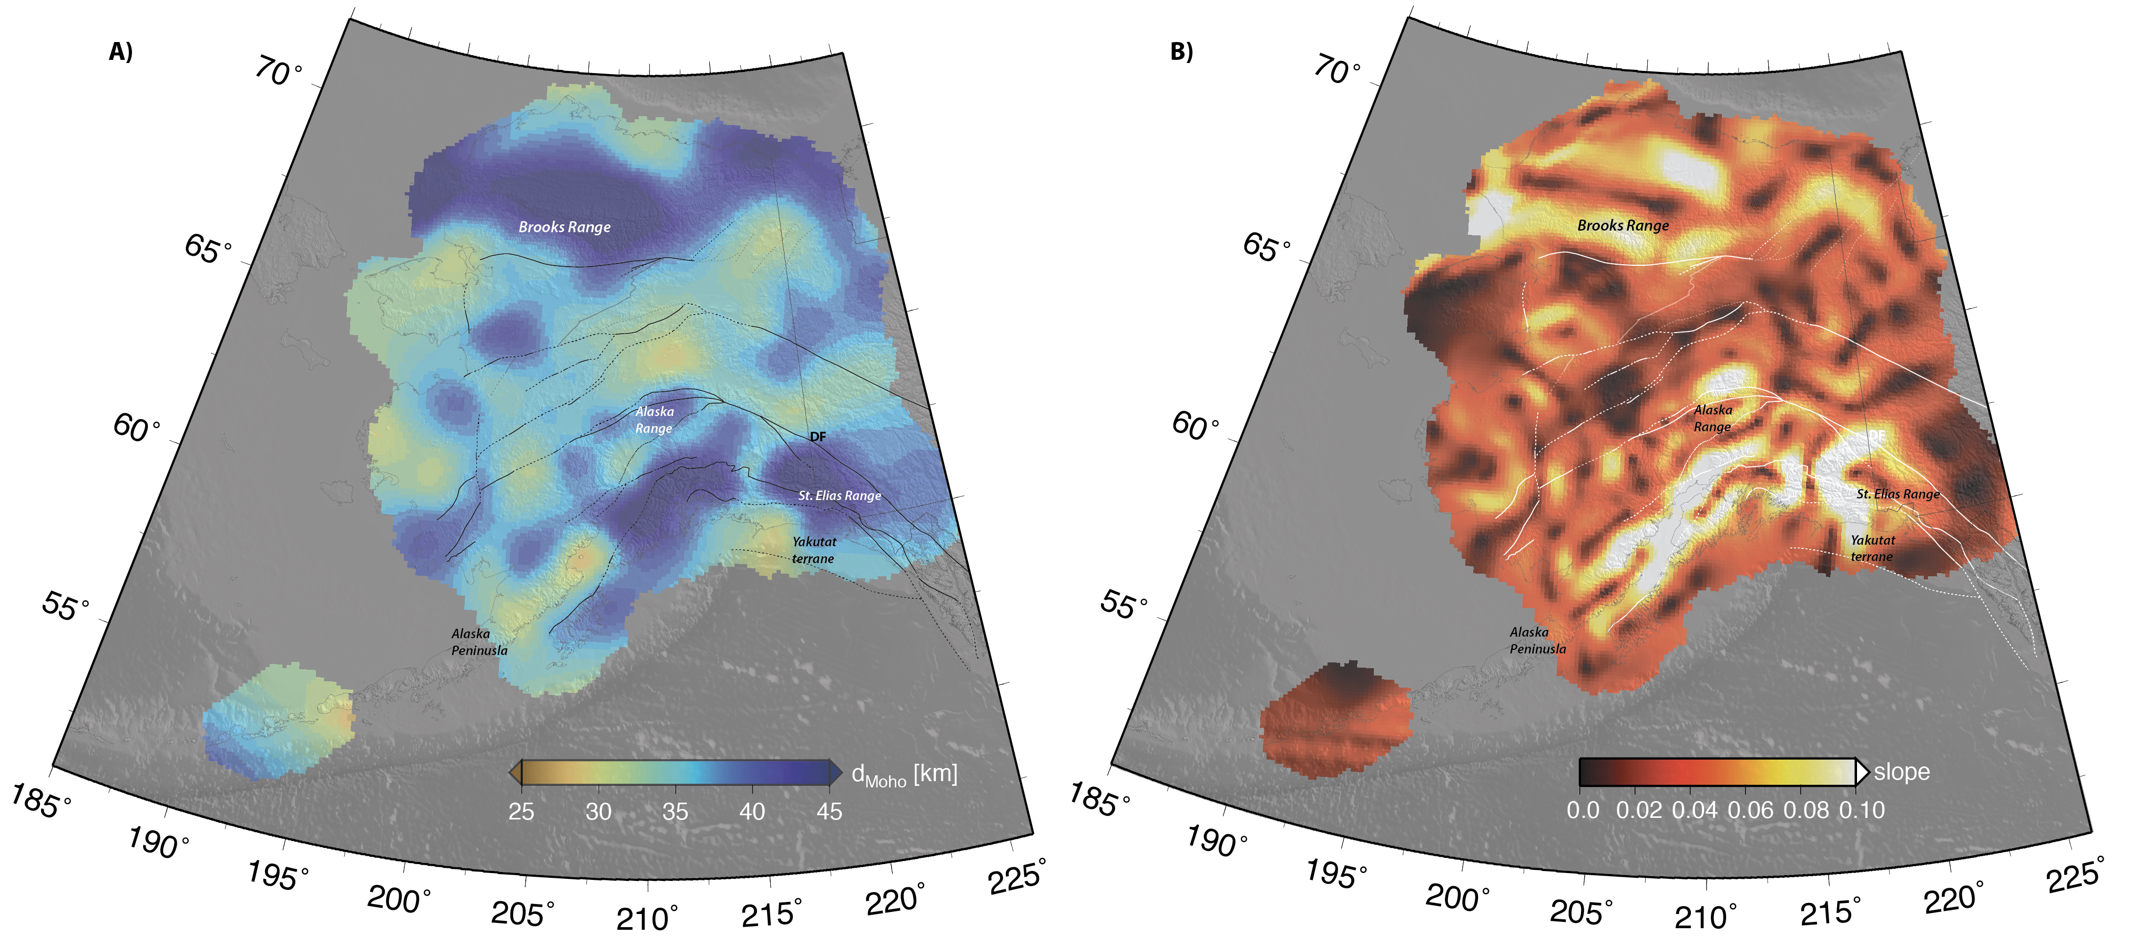

*Figure 5. (a) Moho surface computed from the procedure described above. (b) Slope of the Moho surface in (a). Major faults are indicated with thin black and white lines, dashed where approximately located.*

### Model: data files and software

The models are provided in a python package miller_alaskamoho_srl2018 (<https://pypi.org/project/miller_alaskamoho_srl2018/>) that can be installed through the pip python package management system. The package includes documentation in the form of example jupyter notebooks. Installation instructions are available in the electronic supplement to this article.

The model itself takes the form of 1) a numpy record array containing the raw Moho data plus the model statistics reported above and the model scoring used to perform the surface fitting, and 2) a numpy array of longitude, latitude, depth for the Moho surface and Moho slope ($s=|∇h|$ where $h$ is the depth of the Moho surface) computed on a dense, regular triangulation. The models are accessed through the package as instances of a class that includes the relevant triangulation and interpolation methods (see electronic supplement for details).

We supply three alternative versions of this surface as discussed above: 1) our preferred ensemble average model constructed from all models that lie within 1.25% of each of the end member cases as shown in Figure 5A, 2) the smooth end-member that minimizes the misfit of the test data alone, and 3), the end member that minimizes the misfit of all the data: test and training sets combined.

We also provide the source code in the form of jupyter notebooks to process the raw data, to evaluate the model errors and to compute and interpolate the fine grid surfaces and their gradients. These notebooks also allow the evaluation of other ensembles of models. We supply example python code to read the data files, convert to various formats, and interpolate the surface for plotting (instructions for accessing the models and software are available in the electronic supplement to this article).

## Summary

Our maps of the Moho beneath Alaska and the surrounding regions are based upon hand picks from P receiver function station stacks calculated with Funclab (Eagar and Fouch, 2012; Porritt and Miller, 2018) for all available stations between 1999 and April 2018. The receiver function stacks provide an average Moho depth based upon a simple 1D velocity model conversion. These depths are then used to produce an interpolated surface to predict the Moho across the region, and to provide a measure of the confidence in such a map. Future improvements will result for additional data collected by the TA and other permanent stations. This new data and constraints, or other data products such as EARS (IRIS DMC, 2010), can be easily incorporated into the map and into the Jupyter notebook scripts that generate the Moho surface and the associated measures of confidence.

### **Data and Resources**

The broadband seismic data used to produce the P receiver functions and resulting maps are available from the IRIS Data Management Center at www.iris.edu (last accessed April 2018). The network DOI codes are found in Supplementary Table 1, available in the electronic supplement to this article. The receiver functions and the Moho picks were calculated and edited in FuncLab 1.8.1 (Porritt and Miller, 2018), which is available online at <https://robporritt.wordpress.com/software/>. The figures were made with Generic Mapping Tools (GMT; Wessel and Smith, 1991). We made extensive use of the following python packages: numpy and scipy (Joneset al, 2001) and stripy (Moresi and Mather, available via <https://pypi.org/project/stripy>). The example notebooks use the python cartopy package to generate maps (Met. Office, 2010). The models are provided in a python package miller_alaskamoho_srl2018 available online at (<https://pypi.org/project/miller_alaskamoho_srl2018/>) and described in the electronic supplement to this article.

### **Acknowledgements**

This work is supported by the Australian Research Council Discovery Program DP150102887. Many thanks are due to S.M. Roeske and A. Till for inspiring discussions and encouragement.

**References**

Allam, A.A., V. Schulte-Pelkum, Y. Ben-Zion, C. Tape, N. Ruppert, Z. Ross (2017). Ten Kilometer Vertical Moho Offset and Shallow Velocity Contrast Along the Denali Fault from Double-difference Tomography, Receiver Functions, and Fault Zone Head Waves, *Tectonophysics*. **721** 56-69.

Bassin, C., G. Laske, and G. Masters (2000). The Current Limits of Resolution for Surface Wave Tomography in North America. *EOS Transactions,* ***81***, F897.

Brennan, P.R., H. Gilbert, and K.D. Ridgway (2011). Crustal structure across the central Alaska Range: Anatomy of a Mesozoic collisional zone: *Geochem., Geophys., Geosys.* **12**, doi:10.1029/2011GC003519.

Crotwell, H. P., and T. J. Owens (2005), Automated receiver function processing, [Seism. Res. Lett., 76, 702-708](http://www.seismosoc.org/publications/SRL/SRL_76/srl_76-6_es.html)

Eagar, K.C., and M.J. Fouch (2012). FuncLab: A MATLAB Interactive Toolbox for Handling Receiver Function Datasets, *Seismo. Res. Lett.* **83** 596-603, doi:10.1785/gssrl.83.3.596.

Gilbert, H. (2012). Crustal structure and signatures of recent tectonism as influenced by ancient terranes in the western United States. *Geosphere.* ***8***(1) 141-157. doi: 10.1130/ges00720.1

IRIS DMC (2010), Data Services Products: EARS EarthScope Automated Receiver Survey, <https://doi.org/10.17611/DP/EARS.1>.

Jones E, Oliphant E, Peterson P, et al. SciPy: Open Source Scientific Tools for Python, 2001-, http://www.scipy.org/ [Online; accessed 2018-07-26].

Kennett, B.L.N., E.R. Engdahl, and R. Buland (1995). Constraints on seismic velocities in the Earth from travel times, *Geophys. J. Int.* **122** 108–124.

Levander, A., and M.S. Miller (2012). Evolutionary aspects of the lithosphere discontinuity structure in the Western U.S. *Geochemistry Geophysics Geosystems.* ***13***, doi: doi:10.1029/2012GC004056.

Meltzer, A., R. Rudnick, P. Zeitler, A. Levander, G. Humphreys, K. Karlstrom, E. Ekstrom, C. Carlson, M. Dixon, M. Gurnis, and P. Shearer (1999). The USArray initiative. *Geological Society of America TODAY.* **9** 8-10.

Met Office (2010). *Cartopy: a cartographic python library with a matplotlib interface*, Exeter, Devon.

Miller, M.S., L.J. O'Driscoll, R.W. Porritt, and S.M. Roeske (2018). Multiscale crustal architecture of Alaska inferred from P receiver functions, *Lithosphere*. **10** 267-278. doi.org/10.1130/L701.1

Mooney, W. D., G. Laske, and G. Masters (1998). Crust 5.1: a global crustal model at 5x5 degrees. *Journal of Geophysical Research.* ***103*** 727-747.

Pasyanos, M. E., G. Masters, G. Laske, and Z. Ma (2014). LITHO1.0: An updated crust and lithospheric model of the Earth. *Journal of Geophysical Research.* ***119***(3) 2153-2173, doi: doi:10.1002/2013JB010626

Plafker, G., and H.C. Berg (1994). Overview of the geology and tectonic evolution of Alaska. In G. Plafker & H. C. Berg (Eds.), *The Geology of Alaska*: Geological Society of America.

Porritt, R. W., and M. S. Miller (2018). Updates to FuncLab, a Matlab based GUI for handling receiver functions, *Computers & Geosciences*. **111** 260-271, doi.org/10.1016/j.cageo.2017.11.022.

Renka, R. J. (1997a). Algorithm 772: STRIPACK: Delaunay triangulation and Voronoi diagram on the surface of a sphere. *ACM Trans. Math. Softw.* ***23***(3) 416-434. doi: 10.1145/275323.275329

Renka, R. J. (1997b). Algorithm 773: SSRFPACK: interpolation of scattered data on the surface of a sphere with a surface under tension. *ACM Trans. Math. Softw.* ***23***(3) 435-442. doi: 10.1145/275323.275330

Rosen, J. (2017). Seismic array shifts to Alaska. *Science,* **358** (22) 10.1126/science.358.6359.22.

Tape, C., Plesch, A., Shaw, J. H., & Gilbert, H. (2012). Estimating a Continuous Moho Surface for the California Unified Velocity Model. *Seismological Research Letters,* ***83***(4), 728-735. doi: 10.1785/0220110118

Trabant, C., Hutko, A.R., Bahavar, M., Karstens, R., Ahern, T., and Aster, R. (2012). Data Products at the IRIS DMC: Stepping Stones for Research and Other Applications: *Seismo. Res. Lett.*, **83**, 846-854, doi:10.1785/0220120032.

Wessel, P., and W. H. F. Smith (1991). Free software helps map and display data, Eos Trans. AGU **72**, 441 and 445–446.

Wilson, F.H., Hults, C.P., Mull, C.G., and Karl, S.M., comps., (2015). Geologic map of Alaska: U.S. Geological Survey Scientific Investigations Map 3340, **197**, 2 sheets, scale 1:584,000, doi.org/10.3133/sim3340.

**Supplementary Figures**

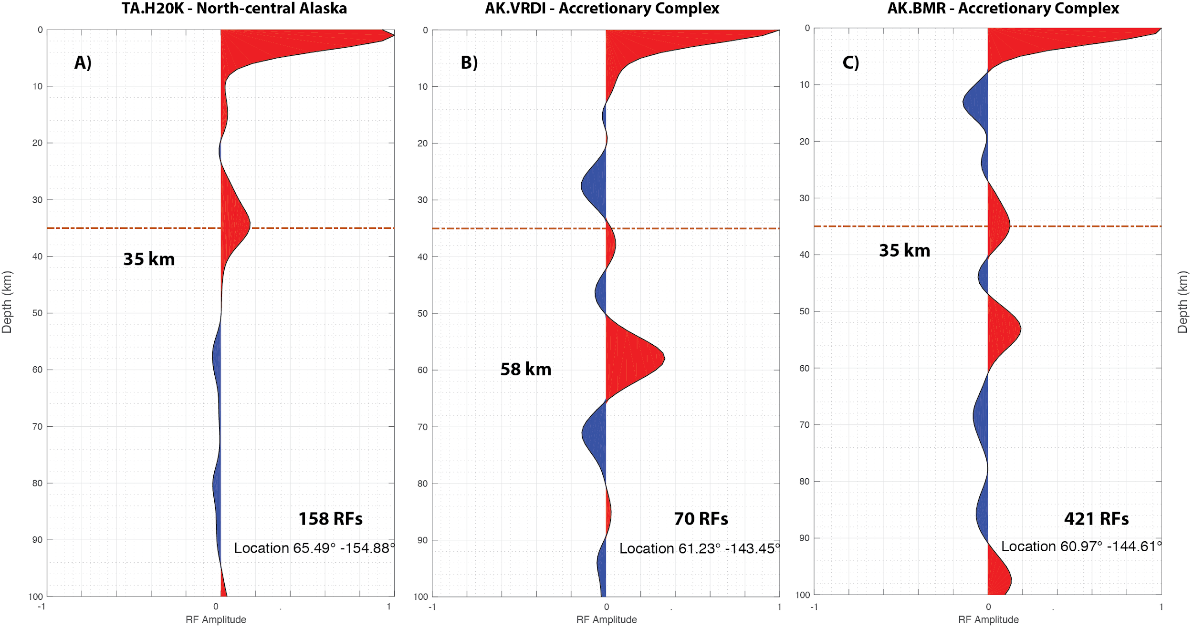

*Figure S1. Receiver gathers for three stations A) TA.H20K, B) AK.VRDI, and C) AK.BMR with locations indicated in Figure 1 and in the lower right of each panel. The first large amplitude positive amplitude signal (in red) at depth is interpreted to be the Moho signal, with the depth (in km) indicated in each panel as picked within the Funclab (see Porritt and Miller, 2018) picking routine. The orange line marks 35 km depth. The number of receiver functions (RF) used to create the gather is listed in the bottom right of each panel.*